Department of Mathematics QR code and Blogger link for
e-content

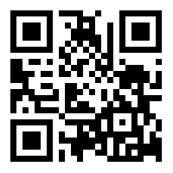

https://nandanammaths18.blogspot.com

